
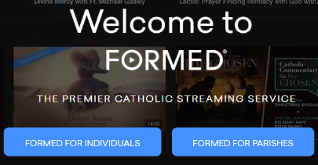
Accessing Resources on FORMED.ORG
- Sign Up
- Visit FORMED.org
- Choose FORMED FOR PARISHES
- Click on FIND YOUR PARISH SUBSCRIPTION

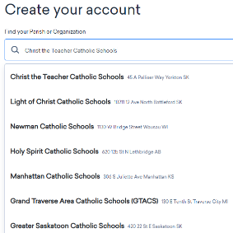

- Find Christ the Teacher Catholic Schools by parish name, location, or zip code
  - Enter Christ the Teacher Catholic Schools in the search bar
  - Click on our division name with our Yorkton address
  - Click Next

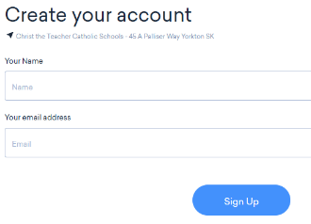
- Enter your email (Must be CTTCS email – Outlook or Gmail, either should work for staff; Gmail for students) - and you're in!
  - Families can access the resource by using a child’s email who is a student in Christ the Teacher Catholic School Division – CTTCS Gmail account; ___@cttcsed.ca

- Select a tab at the top of the home page to find various resource possibilities or click on the search icon to enter what you might be specifically interested in.


You can also scroll on the home page and find different ‘categories’ – much like on Netflix or other streaming services… such as This Week on FORMED, Kids, Saints, Recently Added and Coming Soon, What’s Trending, The Blessed Virgin Mary, Bible Study, Small Group Studies, The Sacraments, FORMED’s Favourites, Mental Health and Faith, Faith & Science, etc.
For specific Liturgical seasons at certain times of the year, there used to be a tab for that season such as Advent, Lent, etc. as shown in the images below – before the update. However, with the latest updates, I’m not sure how that will look. Time will tell.
Many of the tabs have drop down menus as indicated by the down arrow. Once you make your choice, you again scroll down to see the variety of resource options.
- If you’d like to find the various resources categorized in more specific ways, choose the Help tab and then Leaders Resources.
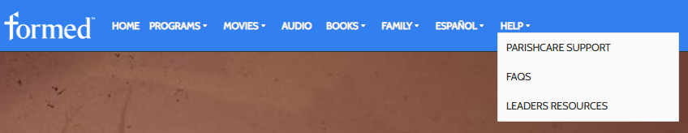

- If the help tab is not visible, you can find it in the drop-down menu where you are logged in. The help tab should then be available, and you can choose Leaders Resources.

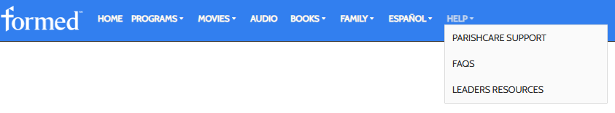
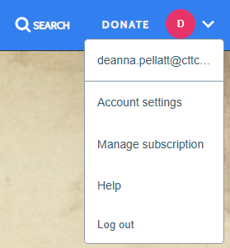

This is what opens once you click on LEADERS RESOURCES.
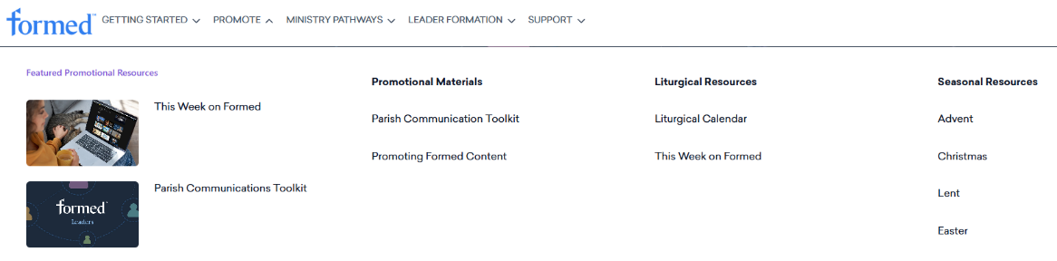

- Choose Seasonal Resources. With the latest update, they are under the Promote tab as shown above (rather than having their own tab on the Leaders Resources bar).

- Choose the season from the drop-down menu – Advent, Christmas, Lent, Easter as shown in the image above – that is applicable to the current season.

- Feel free to check out anything on the page you open. As you scroll down you will see links to access various resources. Be sure to scroll all the way to the bottom to see all the options.

Another Pathway
- When you are in the Leader Resources - #3 and 4 above, you can select ‘Ministry Pathways’ to access ‘Religious Education and Schools.’

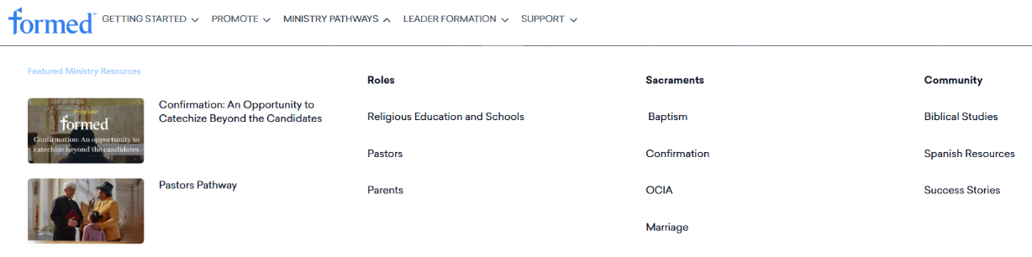

- Once there, you can scroll down to find resources/top recommendations categorized for Elementary School, Middle School, and High School as well as many other resources and resource suggestions such as…
- Resources organized according to the Liturgical Calendar
- Bible Stories for Little Children
- Animated videos that make Bible stories come to life
- Resources related to science, history, literature, music, and art
- You simply have to look for the embedded links in the bullet points as you scroll through the Best Practices information

The latest update appears to have created some changes to what I was used to using and to what I had shared in previous access instruction documents. I’ve tried to update the above information as accurately as possible, but sometimes it simply takes maneuvering through the site to find all that it has to offer.
As you explore, you will find much more! These are just some of the pathways I have discovered as I continue to peruse and use the resource. If you find particularly helpful resources that you think others should be aware of, please let me know and I will be happy to pass that information on.
deanna.pellatt@cttcs.ca

