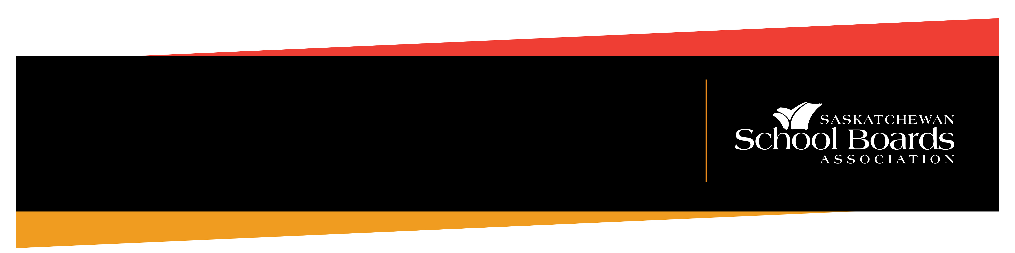

REGINA – School boards throughout the province will again officially recognize “Orange Shirt Day”, on Monday, Sept. 30, together with communities across the country, as requested annually by the Saskatchewan School Boards Association (SSBA).

Sept. 30 has also been proclaimed federally in Canada as National Day for Truth and Reconciliation.

“On behalf of Saskatchewan’s 27 school boards, the SSBA is encouraging everyone to participate in Orange Shirt Day,” said Jaimie Smith-Windsor, president of the SSBA. “This day represents an opportunity for our school communities, and all residents of the province, to expand our understandings, to reflect on the history and harmful legacy of residential schools, and to commit to growing together and toward reconciliation.”

To provide opportunity to unite in a spirit of reconciliation and hope for our future generations, Orange Shirt Day is part of a larger movement in the country.

This day was first proclaimed in Saskatchewan in 2016, and the Government of Saskatchewan proclaims the day every year at the request of the SSBA.

-30-

For more information, please contact:
Joe Couture
Communications
Saskatchewan School Boards Association
Cell: 306-502-3546
Email: jcouture@saskschoolboards.ca

Sept. 27, 2024
RELEASE
MEDIA
ORANGE SHIRT DAY UPCOMING IN SASKATCHEWAN

